**Assignment 25.3**

* **First we create table employee using create command**

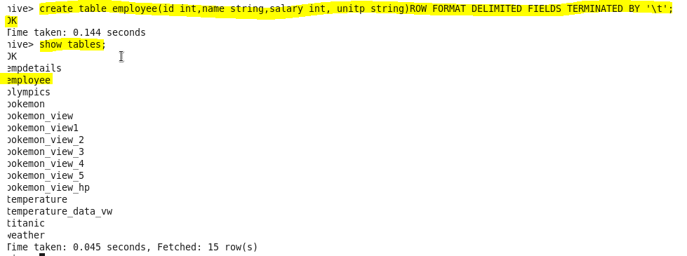

* **load dataset employee.txt using LOAD command**

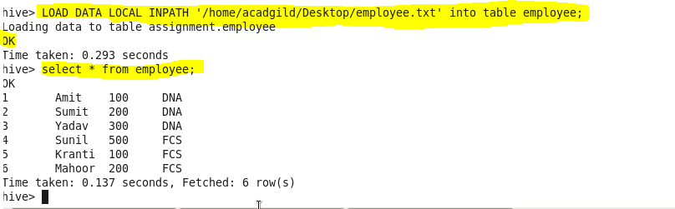

* **Get list of employees who receive a salary less than 100, compared to their immediate employee with higher salary in the same unit**

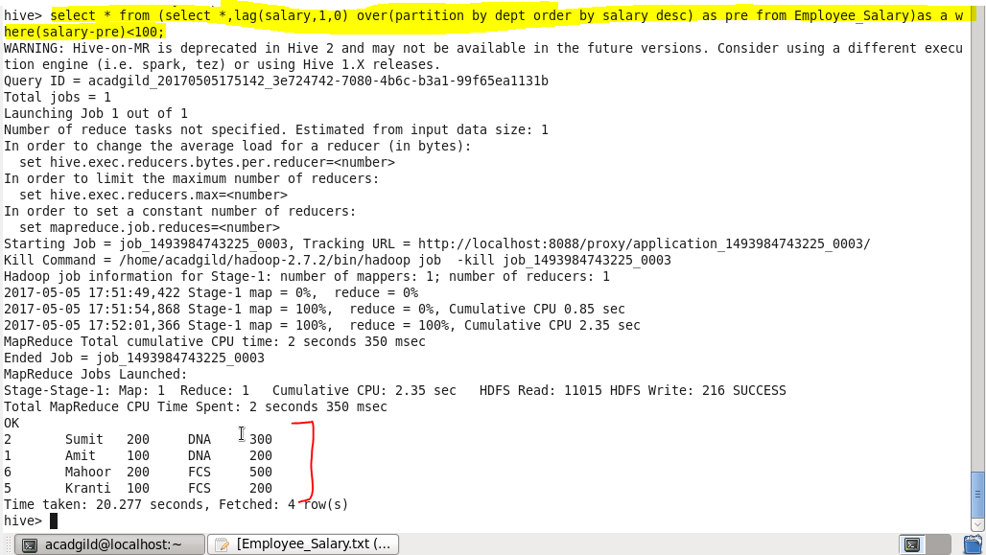

* **List of all employees who draw higher salary than the average salary of that department**

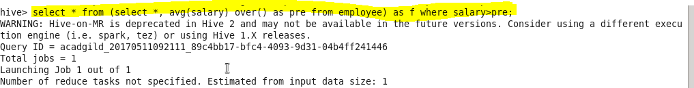

**Output:-**

